Java 8 Optional Class
https://javaconceptoftheday.com/java-8-optional-class/

Null Handling : Before & After Java 8
Null represents an absence of a value. Before Java 8, if-constructs are used to handle the null values. For example, have a look at the below code.
1  2  3  4  5  6  7  8  9  10  11  12  13  14  15  16  17  18  19  20  21  22  23  24  25  26  27  28  29 | class Person  {  House house;  public House getHouse()  {  return house;  }  }  class House  {  HouseLoan houseLoan;  public HouseLoan getHouseLoan()  {  return houseLoan;  }  }  class HouseLoan  {  String houseLoanDetails;  public String getHouseLoanDetails()  {  return houseLoanDetails;  }  }

In the above example, if Person doesn’t own a House, then the value of house will be absent. If Person owns a House and that House is not built with HouseLoan, then the value of houseLoan will be absent.
Below code shows how the absence of values are handled using if-constructs to avoid NullPointerException.
1  2  3  4  5  6  7  8  9  10  11  12  13  14  15  16  17  18  19  20  21  22 | Person person = new Person();  //Null check for person  if (person != null)  {  House house = person.getHouse();  //Null check for house  if (house != null)  {  HouseLoan houseLoan = house.getHouseLoan();  //Null check for houseLoan  if (houseLoan != null)  {  System.out.println(houseLoan.getHouseLoanDetails());  }  }  }

You can notice that for each null check, an extra if-construct is required. It makes code more imprecise and less readable. And it also doesn’t solve the NullPointerException. It just hides it and transfers it to the next level.
Java 8 provides most efficient way to handle the absence of a value. What you have to do is, whenever you feel that a particular property may not contain a value, you declare it as Optional.
For example, in the above example, house property of Person class may not contain a value, then you have to declare it as an Optional of House type. And same applies to houseLoan property of House class.
Below is the modified code with Java 8 Optional class.

1  2  3  4  5  6  7  8  9  10  11  12  13  14  15  16  17  18  19  20  21  22  23  24  25  26  27  28  29  30  31  32  33 | class Person  {  //house declared as an Optional  Optional<House> house;  public Optional<House> getHouse()  {  return house;  }  }  class House  {  //houseLoan declared as an Optional  Optional<HouseLoan> houseLoan;  public Optional<HouseLoan> getHouseLoan()  {  return houseLoan;  }  }  class HouseLoan  {  String houseLoanDetails;  public String getHouseLoanDetails()  {  return houseLoanDetails;  }  }

Working With Java 8 Optional Class :
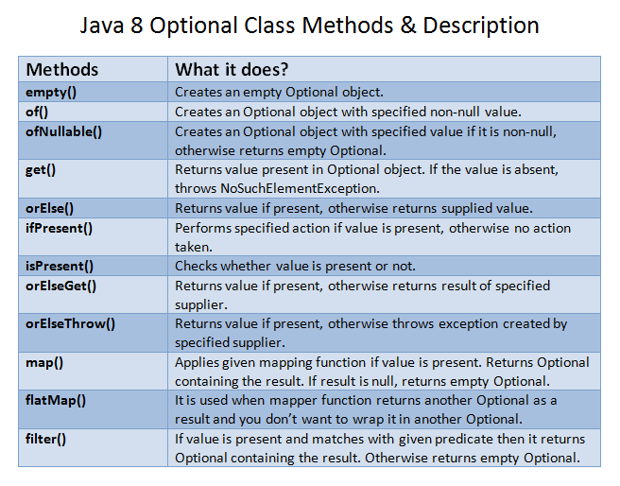
1) Instantiation :
Optional.empty(): It creates an empty optional object.
Optional<House> house = Optional.empty();
Optional.of(): It creates an Optional object with specified non-null value.
Optional<House> house = Optional.of(new House());

Optional.ofNullable(): It creates an Optional object with specified value if the value is non-null. If the value is null, it returns an empty Optional.
House house = new House();
Optional<House> optionalHouse = Optional.ofNullable(house);
2) Extraction :
get(): This method returns the value present in the Optional object. If the value is absent, throws NoSuchElementException.
Optional<House> optionalHouse = Optional.of(new House());
optionalHouse.get();
orElse(): It Returns the value present in the Optional object. If the value is absent, returns the supplied value.
Optional<House> optionalHouse = Optional.of(new House());
optionalHouse.orElse(new House());
ifPresent(): Performs the specified action if the value is present, otherwise no action taken.
Optional<House> optionalHouse = Optional.of(new House());
optionalHouse.ifPresent((House house) -> house.getHouseLoan());
isPresent(): Returns true if the value is present, otherwise returns false.
Optional<House> optionalHouse = Optional.ofNullable(new House());
System.out.println(optionalHouse.isPresent()); //Output : true
orElseGet(): Returns the value if the value is present, otherwise returns result of specified supplier.
Optional<House> optionalHouse = Optional.ofNullable(new House());
optionalHouse.orElseGet(() -> new House());
orElseThrow(): Returns the value if the value is present, otherwise throws an exception created by the specified supplier.
Optional<House> optionalHouse = Optional.ofNullable(new House());
optionalHouse.orElseThrow(() -> new NoSuchElementException());
3) Mapping & Filtering :
map(): If the value is present, applies given mapping function to it and if the result is null, returns empty Optional. Otherwise returns Optional containing the result.
Optional<House> optionalHouse = Optional.ofNullable(new House());
optionalHouse.map((House house) -> house.getHouseType());
flatMap(): This method is similar to above map() method. But, it is used when mapper function returns another Optional as a result and you don’t want to wrap it in another Optional.
Optional<House> optionalHouse = Optional.ofNullable(new House());
optionalHouse.flatMap(House::getHouseLoan).map(HouseLoan::getHouseLoanDetails);
filter(): If the value is present and that value matches with the given predicate, then it returns Optional containing the result. Otherwise returns empty Optional.
Optional<House> optionalHouse = Optional.ofNullable(new House());
optionalHouse.filter((House house) -> house.getHouseType() == “Heritage”)
.flatMap(House::getHouseLoan)
.map(HouseLoan::getHouseLoanDetails);
Also Read :
- Java 8 Optional Class JavaDoc
- Java 8 Streams
- Java 8 Lambda Expressions
- Java 8 Functional Interfaces
- Java 8 Collectors
- Java 8 StringJoiner
- Java 8 Method References
- Java 8 Interface changes

https://www.baeldung.com/java-optional

